

NEWS RELEASE
For Immediate Release

Date: November 4, 2015

MAYOR JOHN LEE WELCOMES NEW CLARK COUNTY
CREDIT UNION BRANCH TO NORTH LAS VEGAS

Las Vegas, NV – On October 26, 2015, a new Clark County Credit Union (CCCU) branch was welcomed to City of North Las Vegas by Mayor John Lee, several elected officials, credit union board members and employees, and residents.
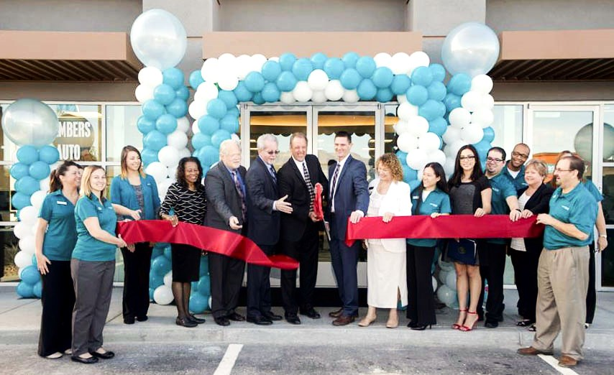
“We were very pleased to see the amount of community support we had for our first official day of business," said CCCU President and CEO, Matthew Kershaw. “The branch opening represents the culmination of considerable planning and teamwork, and we are happy to finally welcome North Las Vegas customers through our doors.”

CCCU is the only state-chartered credit union specifically designated for City of North Las Vegas employees. Along with new exterior and upscale interior design, the new location will provide an array of services, which is unlike any CCCU location in the Las Vegas Valley.

In its 64-year history, CCCU has been at the forefront of offering exemplary service and benefits to its members. The addition of the North Las Vegas branch will add increased benefit and service offerings to members by providing greater access and other conveniences that will enhance the member-owners’ banking experience. The state-of-the-art CCCU North Last Vegas Branch is located at 6120 N. Decatur, #105.

*Photo cut line—
(Top photo) Ribbon-Cutting
(l-r) Julie Goe, Kelly Turner, Brianne Peterson, CCCU board member Debbie Conway, CCCU Board Chair Eric Jorgenson, Assemblyman and CCCU board member Glenn Trowbridge, North Las Vegas Mayor John Lee, CCCU CEO Matt Kershaw, Clark County Clerk Lynn Goya, Branch Manager Tina Ferradino, Arianna representing Congressman Cresent Hardy, Rekey Garcia, Darrick Marshall, CCCU VP-HR Lynn Reiter, Gerardo Ortega.

(Bottom photo) Interior of the new North Las Vegas branch of Clark County Credit Union off of 215 and N. Decatur

ABOUT CLARK COUNTY CREDIT UNION
Founded in Clark County, Nevada in 1951, Clark County Credit Union serves 36,300 Clark County, City of Henderson and City of Las Vegas employees, medical professionals, members of Nevada Public Radio (KNPR) and numerous selected employer groups. Clark County Credit Union has assets of $572 million and six branches throughout Southern Nevada.

For more information about Clark County Credit Union visit: ccculv.org.

-###-

Contact:
Reporters may contact
Lori Goodwine, CIM Marketing Partners, 1.702.944.2464
lgoodwine@cimmp.com

